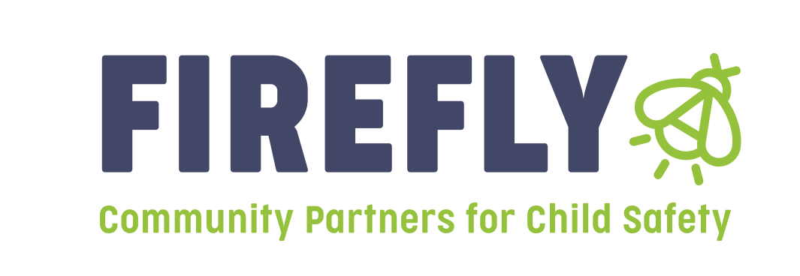
Announcement: Bidders Conference for Prevention funding will be held on March 26th, at 9:30 am

Firefly Children and Family Alliance will be hosting a Bidder’s Conference for Prevention Dollars in Marion County on March 26th, at 9:30am. Please attend the Bidders Conference to receive information and guidelines on how to complete a letter of intent; what is needed to apply; and to receive general information. If you plan to apply for funding, attendance at the Bidder’s Conference is mandatory. Our vision of inclusive and healthy communities of thriving people is only made possible through strong partnerships. Please bring only two people per agency, to allow all agencies to participate. The Bidders conference will be held at the following address:

Firefly Children and Family Alliance
Family Support Center
1575 Dr. Martin Luther King Street
Indianapolis, IN 46202

Firefly Children and Family Alliance will be accepting Letters of Intent for Region 10 providers that wish to apply for funding to provide services that address the prevention of child abuse and neglect. Letters of Intent will be accepted from March 27th, 2026, through April 24th, 2026, at 430 pm. Funding decisions will be announced at RSC in June.

These letters of intent are for those agencies or individuals applying for prevention grants in Marion County Only for the 2026-2027 grant year beginning 7-1-26. All letters of intent should be submitted electronically to all three of the following:

Linda Hayes, Lhayes@fireflyin.org
Jill Kelly, VP of Prevention Services, jkelly@fireflyin.org
Vickie Jones, Regional Director, Vickie.jones@dcs.in.gov

