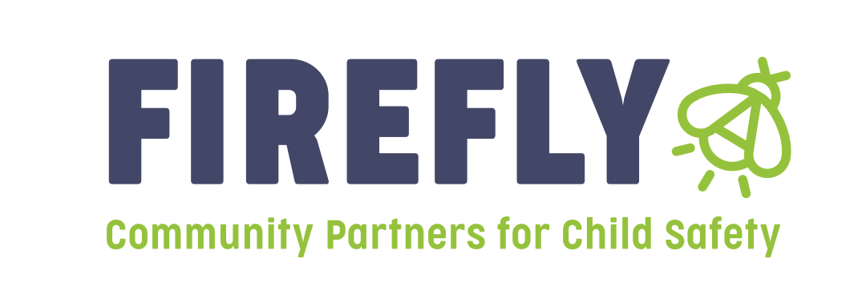

**Request for Letters of Intent**

**Community Based Child Abuse and Prevention Services**

The Department of Child Services Regional Services Council along with Firefly Children and Family Alliance, will be selecting Local Child Abuse Prevention Services to be provided within the Region based on the prevention plan. Local Child Abuse Prevention Services are defined as both primary prevention services and secondary prevention services.

Community Partners will fund both primary and secondary prevention programs. Primary prevention is defined as those services and programs that positively influence families, parents, caretakers, and children in the general population before abuse or neglect occurs. Primary prevention services:

* Are accessible to everyone in the community;
* Are received voluntarily;
* Seek to promote positive family functioning rather than preventing problems;
* Attempt to influence social forces which impact parents and children;
* Are culturally responsive to the program participants, building on the cultural strengths of the family and community; and
* Utilize methods which are educational and supportive, rather than clinical or treatment-oriented.

Secondary prevention services are offered to populations considered “at risk”. Child abuse or neglect may not have occurred within these families, but there is a higher probability that it may occur (or it may have occurred without clear recognition). Secondary prevention services:

* Are offered to a predefined group of vulnerable or “at risk” individuals;
* Are received voluntarily;
* Focus on particular stressors or parenting issues for identified parents and caretakers;
* Seek to promote positive family functioning rather than just preventing problems;
* Build upon participants’ strengths and are not based on a deficit approach; and
* Offer solutions oriented to specific program participants, building on the cultural strengths of the family and community.

The goals or objectives of prevention services are:

* To promote the safety of children
* To reduce the number of children being removed from their parents, guardians, or custodians
* To promote the efficiency of programs and services by coordinating available resources
* To prevent or reduce the number of children who are victims of child abuse, neglect, exploitation, or delinquency

**Proposals will be accepted for the following prevention categories:**

* Support families affected by substance abuse and domestic violence.
* Provide parenting education, violence prevention, and family bonding initiatives that strengthen protective factors.
* Increase knowledge of internet safety, safe relationships, and community awareness of abuse and neglect.
* Directly prevent children and families from becoming involved with the Department of Child Services while ensuring child safety.
* **Mental Health and Well-Being Programs**: Address emotional regulation and coping skills.
* **Early Childhood Intervention**: Provide developmental and educational support to young children to reduce future risks.
* **Community-Based Support Networks**: Offer peer mentorship, parental support groups, and resource navigation services.

Requirements to be eligible for Brokered Dollars:

* Must provide proof of liability insurance
* Must comply with state requirements regarding criminal checks, cps checks, fingerprinting, and local law enforcement checks
* Must comply with state contracts regarding funding
* Must provide services to children and families not involved with the Indiana Department of Child Services or Juvenile Probation
* **NEW THIS YEAR:**

**All Proposals must be titled/labeled in the following consistent format to be considered. Please title by agency name, underscore, program name, underscore and the year. Below is an example:**

**Agency name_ program name_2025**

**Example: ABC Services _Child Wellness_2025**

**Proposals will not be reviewed if they are titled Firefly Children and Family Alliance.**

Additional Information for Proposals:

* Firefly Children and Family Alliance is requesting proposals in anticipation of receiving the Community Partners for Child Safety Contract from the Department of Child Services. No funding will be awarded nor will any Contracts/MOU’s be issued until the contract/funding has been received officially. Any award recommendation is not binding until a MOU/Contract has been issued and signed by both parties.
* All information is located on Firefly Children and Family Alliance website. Follow the link Instructions for Prevention Grant and then click on your region.
* All letters of intent should be NO more than 3 pages and are due on May 23rd, 2025 by 4:30pm. All agencies submitting grants will receive an acknowledgement email once the letter of intent is received.
* Please keep in mind that an additional electronic communication will be held when funds have been allocated. This communication will include receiving MOU’s, invoices, and a more detailed discussion of billing, fingerprints, etc.
* Proposals should be no longer than 3 pages.
* Proposals are due by Friday May 23rd, 2025 by 4:30pm and should be emailed to: Linda Hayes, [lhayes@fireflyin.org](mailto:lhayes@fireflyin.org)

Jill Kelly, VP of Prevention Services, jkelly@fireflyin.org

**Guidelines/Directions for Completing a Letter of Intent**

All proposals should include each section below.

**Description of the Agency:**

This section should include the following:

Agency background information including a briefly description your agency, including its mission, services offered, geographic area served, number of individuals served, and number of full-time, part-time staff. An organizational chart should also be attached.

**Description of Program Services:**

Please describe the services being provided with requested funding, including background information about the history, any information regarding evidence based services, the target population, how many clients will be served in what county, and how to make referrals to the services. Please include geographic boundaries of the program. Please share who is eligible for your program.

**Definition of how the services help prevent child abuse and neglect:**

Please describe the goals of the program and how these goals prevent child abuse and neglect.

**Budget and Budget Narrative:**

Provide a summary of project budget addressing the type and amount of funds requested, a line item description including staff costs, supplies, space/marketing, or any other costs associated with the project.

NEW this year: We will no longer be utilizing funding for staff salary, you will be reimbursed by service provided. You will need to calculate all expenses, and divide by the number of hours of service or group time. Please provide a unit rate for reimbursement purposes.

Below is a sample Budget:

Staff costs $10,000.00

Curriculum/Materials $ 5,000.00

Will complete 25 presentations, will be reimbursed at $15,000.00/25 presentations=600$ per presentation provided.

**Outcomes expected from the program and how they are measured:**

Please include expected outcomes and the tracking method for these outcomes.

**Please list a Contact person for the program**

Please be aware that payment for brokered dollars is dependent upon funding by the state. Payments are made after funding is received at the Firefly Children and Family Alliance and is often paid in approximately 60 days. All agencies being funded through brokered dollars must be capable of obtaining appropriate liability insurance before a contract can be completed, and must comply with state regulations regarding background checks, fingerprinting, etc.