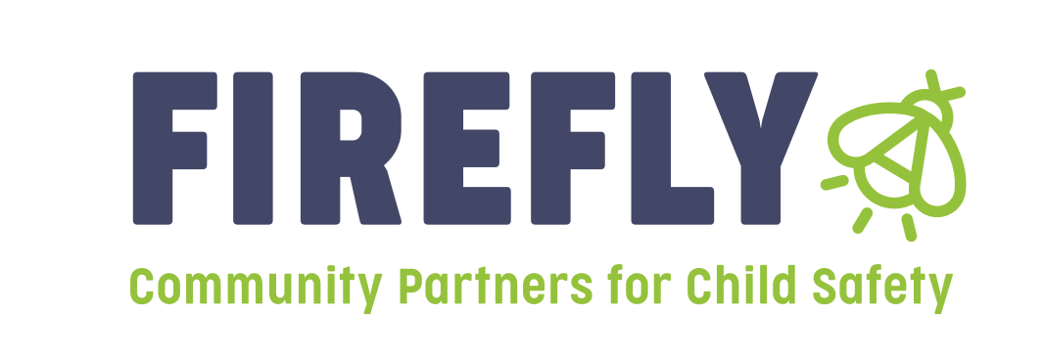

Announcement: Bidders Conference for Prevention funding will be held on April 30th, 2025 at 1:30 pm

Our vision of healthy communities of thriving people is only made possible through strong partnerships. In that essence, Firefly Children & Family Alliance will be hosting a **Bidder’s Conference for Prevention Dollars** in Region 10 on April 30, 2025 at 1:30pm. Attend the Bidder’s Conference to receive information and guidelines on how to complete a “Letter of Intent,” what is needed to apply—and to receive additional general information.

The Bidders conference will be held Virtually. Please join the link below:

Meeting ID: 217 712 751 029

Passcode: cy2zT9gB

[**Join the meeting now**](https://teams.microsoft.com/l/meetup-join/19%3ameeting_YmJjMmUxZGYtN2FkZS00MWI0LTg0ODctMjU1Yzc0OGM4NGNj%40thread.v2/0?context=%7b%22Tid%22%3a%2269c5cecd-41b0-4bed-b30e-29f838c35be2%22%2c%22Oid%22%3a%228180e51f-6434-40ee-9e48-2f1d8ddc9cc9%22%7d)

***You may also email [jkelly@fireflyin.org](mailto:jkelly@fireflyin.org) for an invite.

*Please note: If you plan to apply for funding, attendance at the Bidder’s Conference is mandatory.*

Letters of Intent:

Firefly Children and Family Alliance will be accepting “Letters of Intent” for Region 10 providers that wish to apply for funding to provide services that address the prevention of child abuse and neglect. Letters of Intent will be accepted from April 30, 2025 through May 23, 2025 at 4:30 pm. Funding decisions will be announced at the monthly Regional Service Council meeting on June 20, 2025.

These letters of intent are for those agencies or individuals applying for prevention grants in Region 10 for the 2025-2026 grant year beginning 7-1-25. All letters of intent should be submitted electronically to both of the following:

Linda Hayes, [Lhayes@fireflyin.org](mailto:Lhayes@fireflyin.org)

Jill Kelly, VP of Prevention Services, [jkelly@fireflyin.org](mailto:jkelly@fireflyin.org)