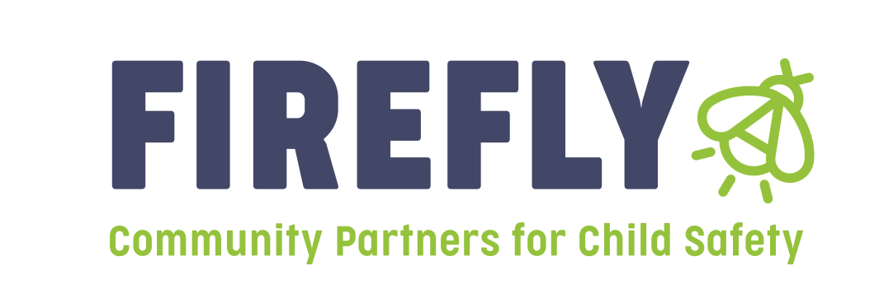

Announcement: Bidders Conference for Prevention funding will be held on April 21st, 2025 at 2:30pm

Our vision of healthy communities of thriving people is only made possible through strong partnerships. In that essence, Firefly Children & Family Alliance will be hosting a **Bidder’s Conference for Prevention Dollars** in Region 8 on April 21st 2025 at 2:30pm. Attend the Bidder’s Conference to receive information and guidelines on how to complete a “Letter of Intent,” what is needed to apply—and to receive additional general information.

The Bidders conference will be held at the following address:

Vigo County Department of Child Services, Conference Room

30 N. 8th Street

Terre Haute, IN 47807

Letters of Intent:

Firefly Children and Family Alliance will be accepting “Letters of Intent” for Region 8 providers that wish to apply for funding to provide services that address the prevention of child abuse and neglect. Letters of Intent will be accepted from April 21, 2025 through May 23rd, 2025 at 4:30 pm. Funding decisions will be announced at the Regional Service Council.

These letters of intent are for those agencies or individuals applying for prevention grants in Region 8 for the 2025-2026 grant year beginning 7-1-25. All letters of intent should be submitted electronically to both of the following:

Linda Hayes, [Lhayes@fireflyin.org](mailto:Lhayes@fireflyin.org)

Jill Kelly, VP of Prevention Services, [jkelly@fireflyin.org](mailto:jkelly@fireflyin.org)

Heidi Decker, Regional Manager, Heidi.decker@dcs.in.gov