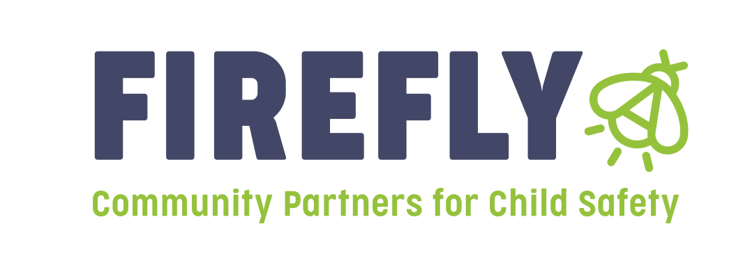

Announcement: Bidders Conference for Prevention funding will be held on April 11th, 2025 at 10:00am

Our vision of healthy communities of thriving people is only made possible through strong partnerships. In that essence, Firefly Children & Family Alliance will be hosting a **Bidder’s Conference for Prevention Dollars** in Region 7 on April 11th 2025 at 10:00am. Attend the Bidder’s Conference to receive information and guidelines on how to complete a “Letter of Intent,” what is needed to apply—and to receive additional general information.

The Bidders conference will be held at the following address:

Delaware County Department of Child Services, Conference Room

3600 W. Kilgore Avenue

Muncie, IN 47304

Letters of Intent:

Firefly Children and Family Alliance will be accepting “Letters of Intent” for Region 7 providers that wish to apply for funding to provide services that address the prevention of child abuse and neglect. Letters of Intent will be accepted from April 14, 2025 through May 16th, 2025 at 4:30 pm. Funding decisions will be announced at the Regional Service Council meeting on June 13th, 2025.

These letters of intent are for those agencies or individuals applying for prevention grants in Region 7 for the 2025-2026 grant year beginning 7-1-25. All letters of intent should be submitted electronically to both of the following:

Linda Hayes, [Lhayes@fireflyin.org](mailto:Lhayes@fireflyin.org)

Jill Kelly, VP of Prevention Services, [jkelly@fireflyin.org](mailto:jkelly@fireflyin.org)

Kelly Broyles, Regional Manager, [kelly.broyles@dcs.in.gov](mailto:kelly.broyles@dcs.in.gov)