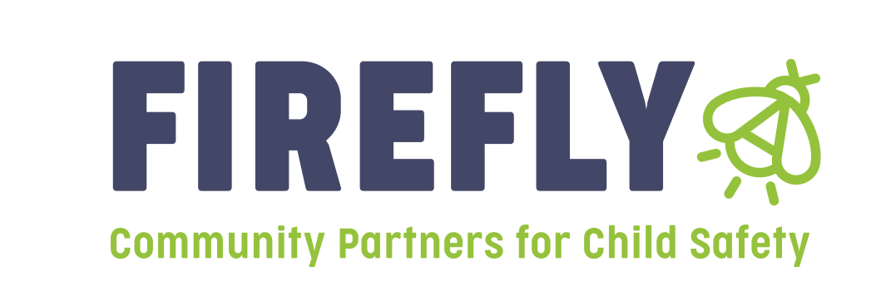

Announcement: Bidders Conference for Prevention funding will be held on April 14th, 2025 at 10:00 am

Our vision of healthy communities of thriving people is only made possible through strong partnerships. In that essence, Firefly Children & Family Alliance will be hosting a **Bidder’s Conference for Prevention Dollars** in Region 14 on April 14th, 2025 at 10:00am. Attend the Bidder’s Conference to receive information and guidelines on how to complete a “Letter of Intent,” what is needed to apply—and to receive additional general information.

The Bidders conference will be held at the following address:

The United Way Building, Conference Room (2nd floor)

1531 13th Street

Columbus, IN 47201

Letters of Intent:

Firefly Children and Family Alliance will be accepting “Letters of Intent” for Region 14 providers that wish to apply for funding to provide services that address the prevention of child abuse and neglect. Letters of Intent will be accepted from April 14th, 2025 through May 9th, 2025 at 4:30 pm. Funding decisions will be announced at the Regional Service Council in May.

These letters of intent are for those agencies or individuals applying for prevention grants in Region 14 for the 2025-2026 grant year beginning 7-1-25. All letters of intent should be submitted electronically to the following:

Linda Hayes, [Lhayes@fireflyin.org](mailto:Lhayes@fireflyin.org)

Jill Kelly, VP of Prevention Services, [jkelly@fireflyin.org](mailto:jkelly@fireflyin.org)