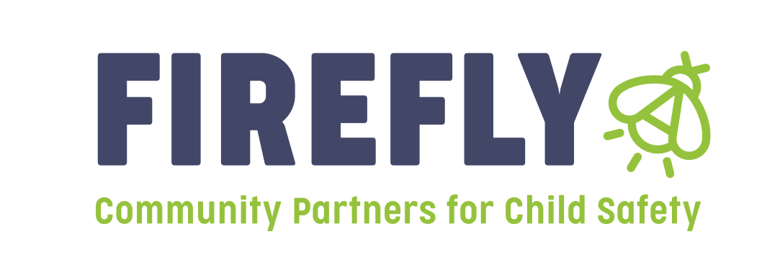
Firefly Children and Family Alliance will be accepting letters of intent from those agencies or individuals interested in applying for prevention grants in Region 7 for the 2023-2024 grant year. This letter of intent is not a full proposal, it should be a one-page document that provides information about the services you wish to provide in the region.

Each letter of intent should include the following:

- Description of Services: What prevention service do you wish to provide? How will the service be implemented and how often? Where will it be held?
- Target audience: Who will enroll in your programming and how will you get referrals?
- Impact on Child Abuse and Neglect: How does your service keep kids safe, keep families from becoming involved in the child welfare system, or promote family well-being?
- Diversity, Equity, Inclusion and Belonging: Our vision of inclusive and healthy communities of thriving people is only made possible through strong partnerships. Therefore, we encourage organizations led by people who represent the diverse identities and lived experiences of the clients and communities we serve to apply.

All letters of intent are due by 5pm On February 22nd, 2023 and should be submitted electronically to both of the following:

- Jill Kelly, VP of Community Based Services, jkelly@fireflyin.org
- Kelly Broyles, Regional Manager, kelly.broyles@dcs.in.gov

Region 7 is hoping to find prevention services that address homelessness, substance abuse, domestic violence, along with child and family well being, mental health, and primary child abuse prevention.

Letters of intent will be reviewed and agencies will be notified by March 17th, 2023 if they are invited to submit a full proposal. If invited to submit a full proposal, guidelines for submission will be provided to the chosen agencies.

