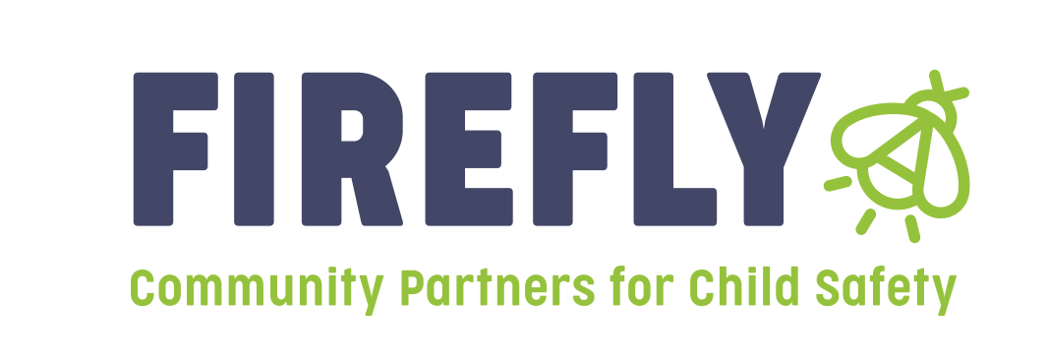
Announcement: Bidders Conference for Prevention funding will be held on March 31, 2023 at 9am

Firefly Children and Family Alliance will be hosting a Bidder’s Conference for Prevention Dollars in Region 10 on March 31, 2023 at 9am. Please attend the Bidders Conference to receive information and guidelines on how to complete a letter of intent; what is needed to apply; and to receive general information. If you plan to apply for funding, attendance at the Bidder’s Conference is mandatory. Our vision of inclusive and healthy communities of thriving people is only made possible through strong partnerships. Therefore, we encourage organizations led by people who represent the diverse identities and lived experiences of the clients and communities we serve to apply. The Bidders conference will be held at the following address:

Firefly Children and Family Alliance
Family Support Center
1575 Dr. Martin Luther King Street
Indianapolis, IN 46202

Firefly Children and Family Alliance will be accepting Letters of Intent for Region 10 providers that wish to apply for funding to provide services that address the prevention of child abuse and neglect. Letters of Intent will be accepted from April 1, 2023 through May 5th, 2023 at 430 pm. Funding decisions will be announced at RSC on June 16th, 2023.

These letters of intent are for those agencies or individuals applying for prevention grants in Region 10 for the 2023-2024 grant year beginning 7-1-23. All letters of intent should be submitted electronically to all three of the following:

Linda Hayes, Lhayes@fireflyin.org
Jill Kelly, VP of Prevention Services, jkelly@fireflyin.org
Peggy Surbey, Regional Manager, Peggy.Surbey@dcs.in.gov

